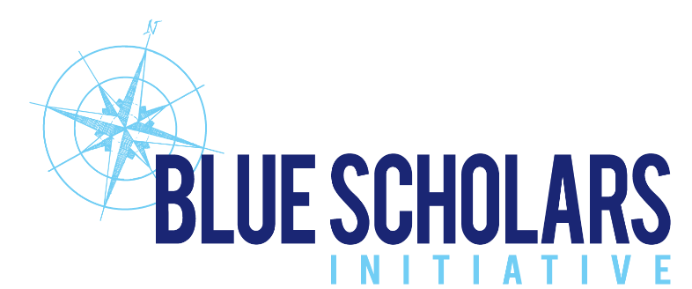
For Immediate Release

For more information contact:
Adam Steckley, Blue Scholars Initiative
asteckley@bluescholars.org
305-984-5074

BLUE SCHOLARS INITIATIVE LAUNCHES
8 DAYS OF WORLD OCEANS CAMPAIGN

Miami, FL (May 20, 2021) – Blue Scholars Initiative, a new marine conservation education program based in Miami, has announced an inaugural campaign known as 8 Days of World Oceans taking place June 1-8, 2021. The announcement was made by Blue Scholars Initiative Co-Directors Adam Steckley and Meredith Bass.

The campaign will kick off on Tuesday, June 1st on the Blue Scholars Initiative digital media platforms and website at BlueScholars.org/world-oceans. Each day, a non-governmental organization (NGO) in a specific part of the world will address the environmental issues facing their discrete ocean region and actions people can take to make a positive difference. Bringing together eight separate marine environmental organizations from across the globe will allow cross-pollination of marine ecology information, ideas and solutions among participants from around the world.

The 8 Days of World Oceans campaign will use brief video presentations on social media to raise global awareness about environmental issues affecting the seven ocean regions of the world. These include the North and South Atlantic Ocean, North and South Pacific Ocean, Southern
Ocean, Indian Ocean and the Arctic Ocean. Each day of the campaign will focus on a specific world ocean region, with the final day (June 8th) dedicated as World Oceans Day, presented by Blue Scholars Initiative.

8 Days of World Oceans Events Schedule (June 1-8 and 12-13, 2021)

June 1, North Atlantic Ocean – Rachael Miller and Ashley Sullivan, Rozalia Project for a Clean Ocean (Sponsored by Coastal Building Maintenance).

June 2, South Atlantic Ocean – Pablo Garcia Borboroglu, Global Penguin Society (Sponsored by TUUCI)

June 3, Southern Ocean – Dr. Rodolfo Werner, Agenda Antartica & Antarctic and Southern Ocean Coalition (Sponsored by Motiv)

June 4, Indian Ocean – Dr. Asha de Vos, Oceanswell (Sponsored by Sanar Naturals)

June 5, South Pacific Ocean – Rodrigo Hucke-Gaete, Centro Ballena Azul (Blue Whale Center) (Sponsored by VS/BROOKS)

June 6, North Pacific Ocean – Melissa Cronin, Manta Trust/Mobula Conservation Project (Sponsored by PADL)

June 7, Arctic Ocean – Henry Huntington, Ocean Conservancy (Sponsored by the Block Family)

June 8, World Oceans Day – Adam Steckley and Meredith Bass of Blue Scholars Initiative (Sponsored by the Roger Tory Peterson Institute)

June 12 and 13 – Join Blue Scholars Initiative and other environmental organizations to celebrate World Oceans Day at the fabulous Faena Hotel located at 3201 Collins Avenue on Miami Beach. Free and open to the public, the weekend will include a number of exciting activities and exhibitions to raise awareness of ocean health and foster environmental stewardship. On Saturday, EarthEcho International, established by Philippe and Alexandra Cousteau, grandchildren of legendary explorer Jacques-Yves Cousteau, will provide instruction on how to test water quality, while VolunteerCleanup.Org, The International SeaKeepers Society and Clean Miami Beach volunteers will comb the coast removing litter from the shoreline.

On Sunday, June 13, the weekend will culminate with a celebration in Faena Hotel’s Mammoth Garden at 6 pm featuring complimentary cocktails and an informative presentation by Elizabeth Wheaton, Director of the City of Miami Beach’s Environment & Sustainability Department, and Dr. Nikki Traylor-Knowles, Assistant Professor of Marine Biology at the Rosenstiel School of Marine and Atmospheric Science. The cocktail reception will be followed by a film screening at Faena Theater at 8 pm.

Blue Scholars Initiative Programs

The primary mission of Blue Scholars initiative, a registered 501(C)(3) organization is to engage Miami fourth- and fifth-grade students in marine biology, ecology and watershed concepts, demonstrating the impacts caused by humans. As a free program, priority is given to children from Title I schools who might otherwise never have the chance to connect with the marine environment.

In the classroom, along the shoreline and from boats, students investigate the rich biodiversity of the ocean, conduct citizen science, and develop a passion for the environment, thus inspiring the next generation of ocean stewards.

Schools and community based organizations being served by Blue Scholars include Meadowlane Elementary, Palm Lakes Elementary, Leewood K-8 Center, Dr. William A. Chapman Elementary, Henry S. West Laboratory School, Miami Beach South Pointe Elementary, Overtown Youth Center, Overtown Optimist Club, Breakthrough Miami and The Home Team.

Blue Scholars Initiative also hosts a number of public programs and events throughout the year in concert with other non-profit organizations focused on protecting the environment and marine education. These include beach cleanups, tree plantings and awareness events which shine the spotlight on the importance of protecting the ocean. In addition to the 8 Days of World Oceans, Blue Scholars Initiative hosts the 12 Days of Biscayne Bay each December to highlight hands-on actions that individuals, families, businesses and communities can take to support a healthy Biscayne Bay and surrounding watershed.

About Blue Scholars Initiative

Blue Scholars Initiative was co-founded in 2019 by South Florida natives and environmentalists Adam Steckley and Doug Brown.

Blue Scholars Initiative offers virtual and waterborne marine science education to fourth and fifth graders in 45-minute lessons, which are aligned to the State of Florida Next Generation Sunshine State Standards for Science.

Students embark on pontoon vessels from marinas on north, south and central Biscayne Bay, study the marine environment up close, the marine food chain, photosynthesis and the importance of the mangrove and seagrass nurseries. They are able to see pelicans diving for fish, dolphins and sea turtles surfacing for air, and eagle rays gliding across the shallow grass meadows.

Climate Change and sea level rise are also discussed, and the students learn of the importance of water quality in sustaining marine life. The children take water samples and identify temperature, pH, salinity, dissolved oxygen and turbidity.

More information is available at https://bluescholars.org/events/world-oceans-celebration and via BSI Social Media:
Instagram, Facebook and LinkedIn - @bluescholarsinitiative
Twitter - @BlueScholarsIn1

###

May 20, 2021

